# ECE6333 Project Report

Zhongqi Zhao

**Code**

My code contains two parts in general, the first one is the basic layout of the Kalman filter. The second part is MMSE estimator for question part 2. The other code is for visualize the result and other subtle objectives.

**Part 1**

The answer is on the MATLAB console. In general, they matched to each other perfectly.

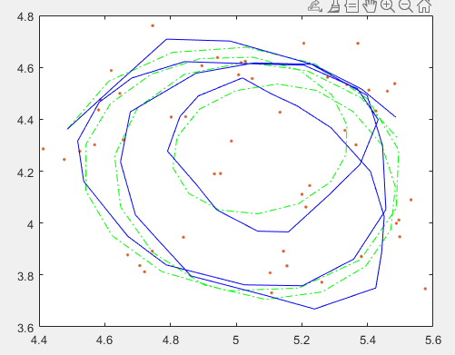**Part 2**

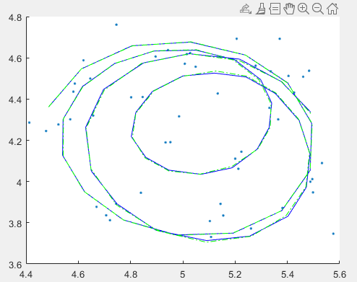Left:

Kalman Filter

Right:

MMSE estimation

Those dots are data point, yellow curve is the actual route, the blue one is the estimation curve.

As we can see in the picture, most of the key points on the curve are adjacent to each other. Hence, they are closely agreed!

**Part 3**

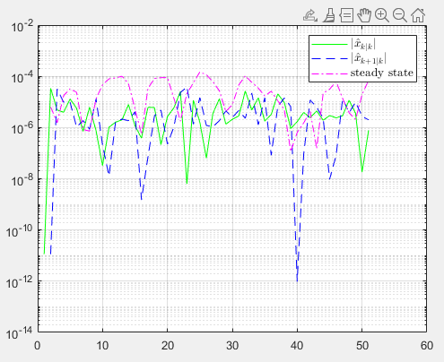

As we can see, the estimation and prediction’s MSE is very close to the zero (10^-4), which means the Kalman does a good job on tracking a moving object.